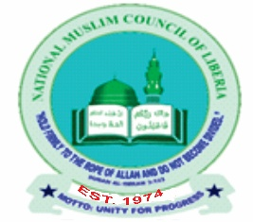
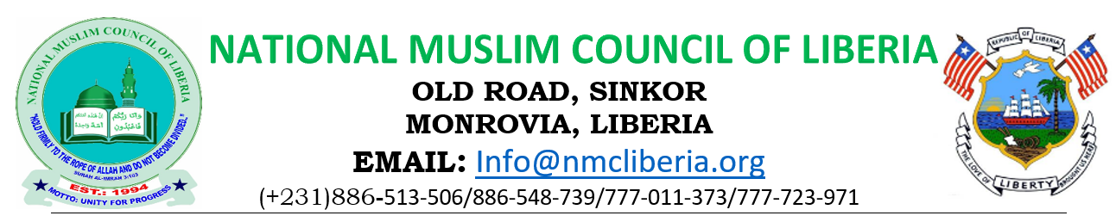

PUBLIC SERVICE ANNOUNCEMENT
April 6, 2026

THIS IS TO OFFICIALLY INFORM ALL REGISTERED MEMBERS OF THE NATIONAL MUSLIM COUNCIL OF LIBERIA (INCLUDING COUNTY MEMBERSHIPS, ORGANIZATIONS/INSTITUTIONS, AND MOSQUES) THAT THE HOLDING OF THE GENERAL ASSEMBLY FOR THIS YEAR HAS BEEN APPROVED AND IS SCHEDULED TO TAKE PLACE FROM APRIL 25–26, 2026.

ACCORDINGLY, ALL REGISTERED MEMBER ORGANIZATIONS/INSTITUTIONS AND MOSQUES ARE HEREBY REQUESTED TO TAKE NOTE AND SUBMIT THE NAMES OF THEIR RESPECTIVE DELEGATES, IN LINE WITH THE PROVISIONS OF THE 2021 CONSTITUTION (THREE DELEGATES PER INSTITUTION), ON OR BEFORE APRIL 15, 2026. THIS WILL ENABLE SMOOTH PLANNING AND COORDINATION OF THE ASSEMBLY.

MEANWHILE, OFFICIAL COMMUNICATIONS ADDRESSED TO EACH REGISTERED MEMBER ORGANIZATION/INSTITUTION, MOSQUES REGARDING THE GENERAL ASSEMBLY ARE AVAILABLE FOR COLLECTION AT THE SECRETARIAT OF THE NATIONAL MUSLIM COUNCIL OF LIBERIA HEADQUARTERS DURING WORKING HOURS.

ALTERNATIVELY, ORGANIZATIONS/INSTITUTIONS AND MOSQUES THAT MAY NOT BE ABLE TO VISIT THE SECRETARIAT IN PERSON ARE ADVISED TO OFFICIALLY SUBMIT THEIR INSTITUTION’S WHATSAPP CONTACT NUMBER TO FACILITATE THE SHARING OF THE COMMUNICATION.

ISSUED BY:
THE SECRETARIAT
NATIONAL MUSLIM COUNCIL OF LIBERIA

